# Project Two README

## About the Project/Project Title

Animal Shelter Web Application

This application is used as a web app that displays a chart of animals within the animals database and allows the user to interact with the chart to show graphs and geolocations of the animals. The database was originally loaded, then the animalShelter.py file was written to interact with the database. Finally the ProjectTwoDashboard.ipynb file was written to display the interaction between the database and the animalShelter.py file. The ProjectTwoDashboard.ipynb file includes code that shows logos, creates a chart that can be filtered and sorted, displays graphs of the sorted data, and a geolocation chart. The geolocation chart and graphs were difficult to implement but due diligence has its rewards as research and tinkering got them to work.

## Motivation

This project is meant to allow the user to interact with the database of animals in order to sort through them and track specific data related to the animals. MongoDB was my choice for development as it has excellent tools for interaction with Python.

## Getting Started

To get started, you will need the animalShelter.py file, Jupyter’s ProjectTwoDashboard.ipynb file. Then the Jupyter file should be run to show the data table and allow the user to interact.

## Installation

You will need the Jupyter Notebook application, animalShelter.py file, the ProjectTwoDashboard.ipynb file, the aac_shelter_outcomes.csv file imported into the mongo database, and finally start the database.

## Usage

This project is meant to allow the user to easily interact with the database to view and sort animal information

### Code Example

This screenshot shows what the radio buttons do when pressed. WR is Water Rescue, MR is Mountain Rescue, and DR is Disaster Rescue. Each radio button specifically searches for the animals in the respective groups.

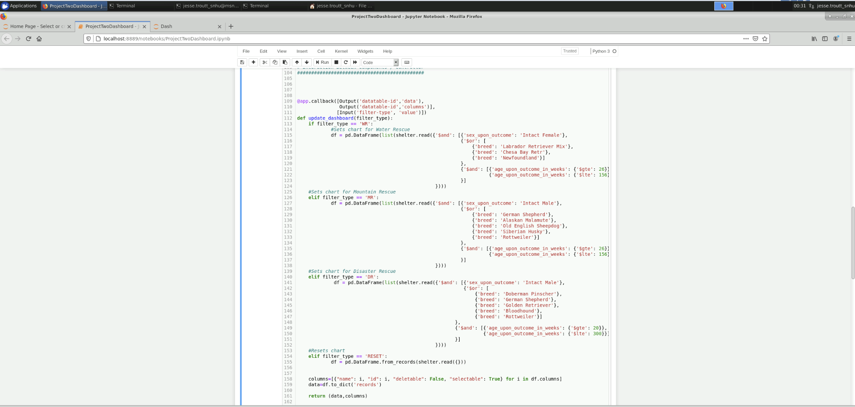

### Tests

These tests show the functionality of the application

Here is the beginning of the application, showing the logo and identifier of the program

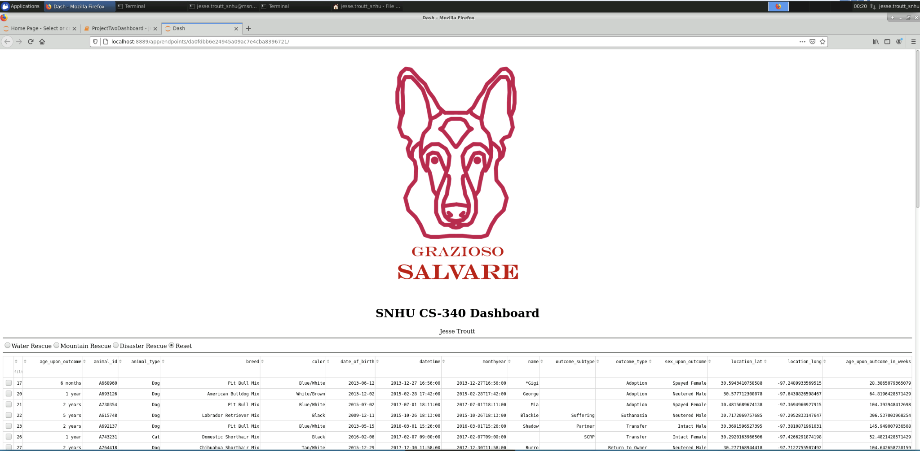

This screenshot shows the data table along with the pie chart and geolocation with selected animal located on the map

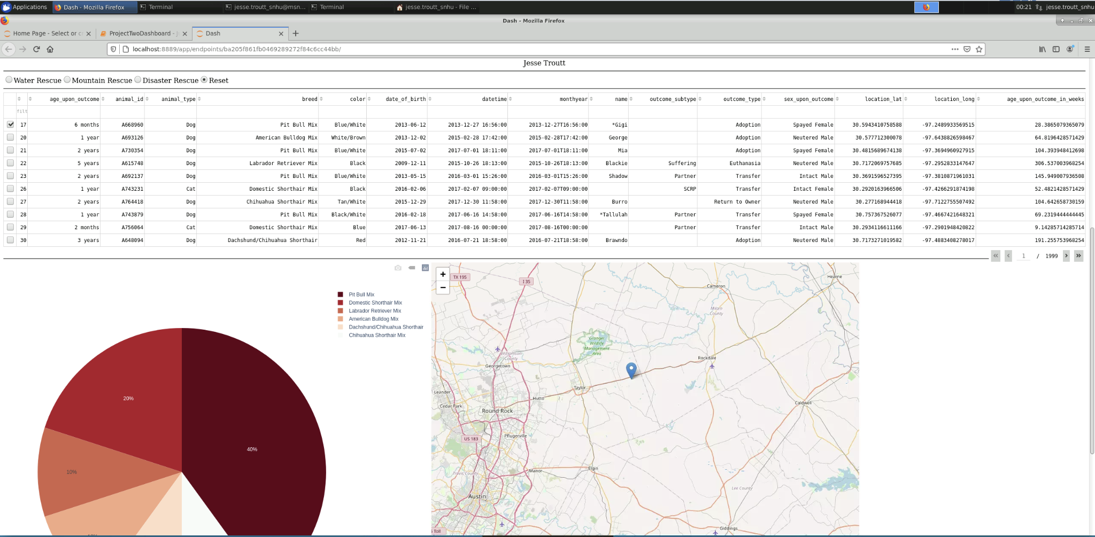

Below is the same table and charts with the Water Rescue radio button selected

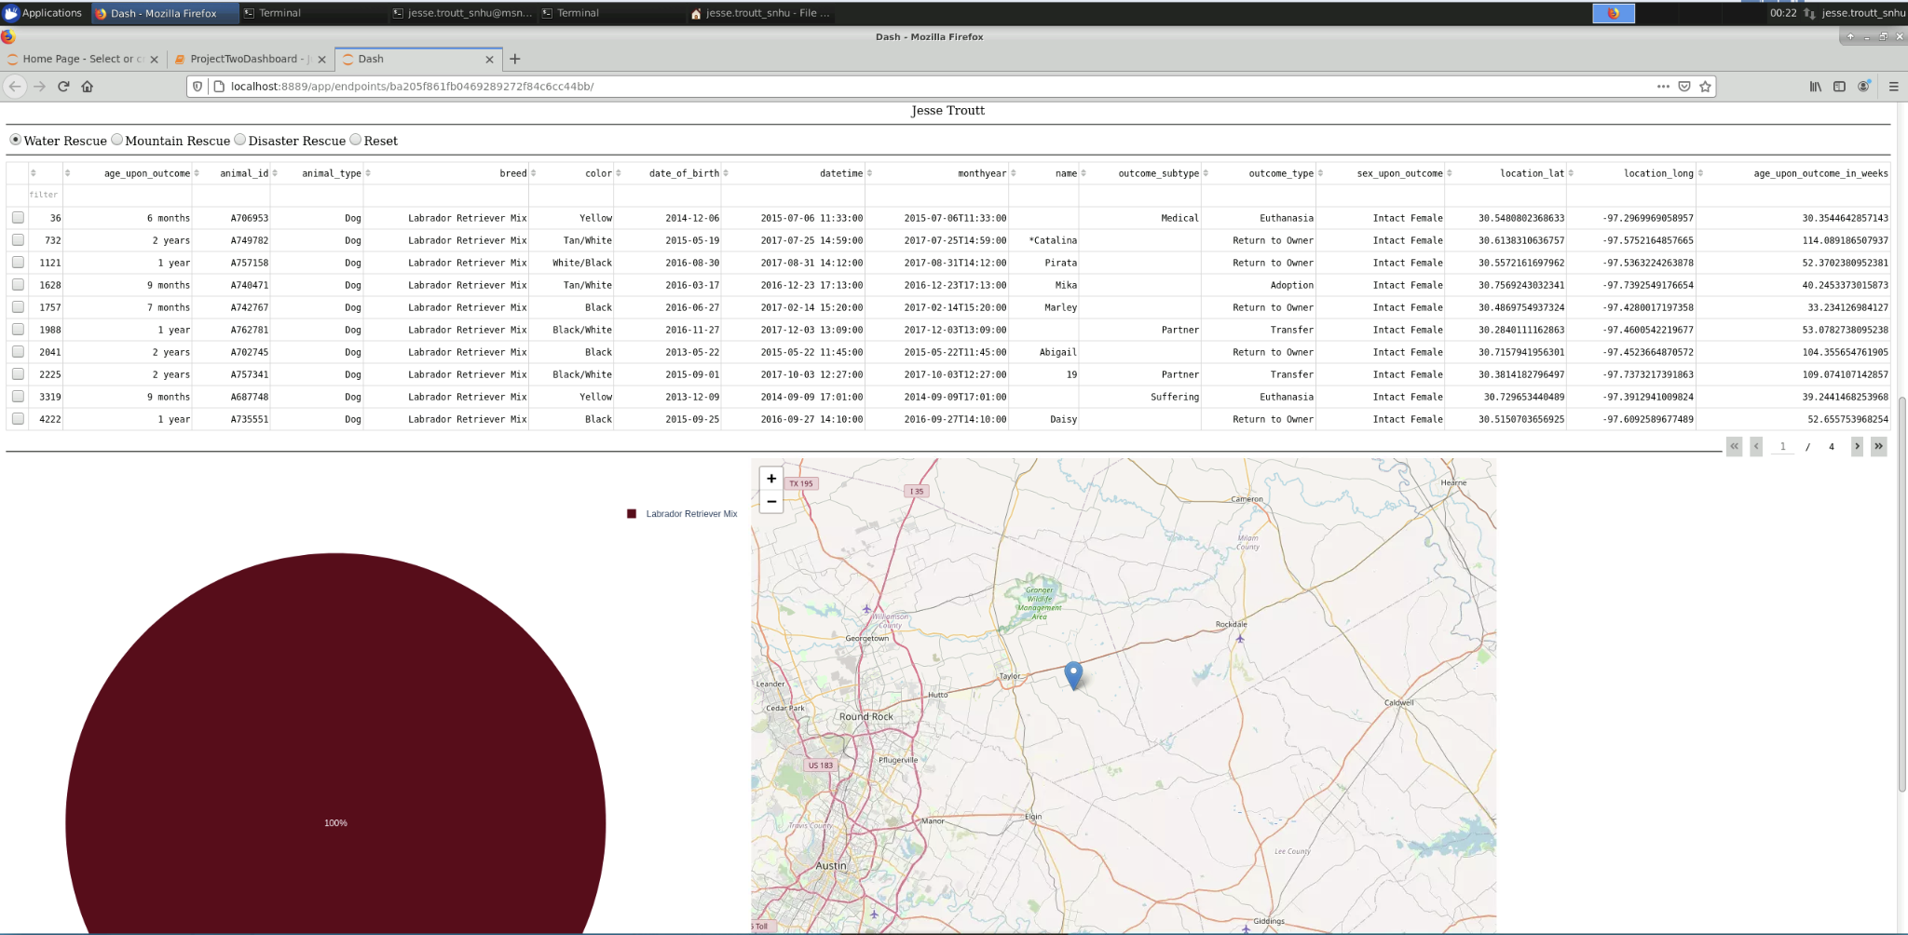

Below is the same table and charts with the Mountain Rescue radio button selected

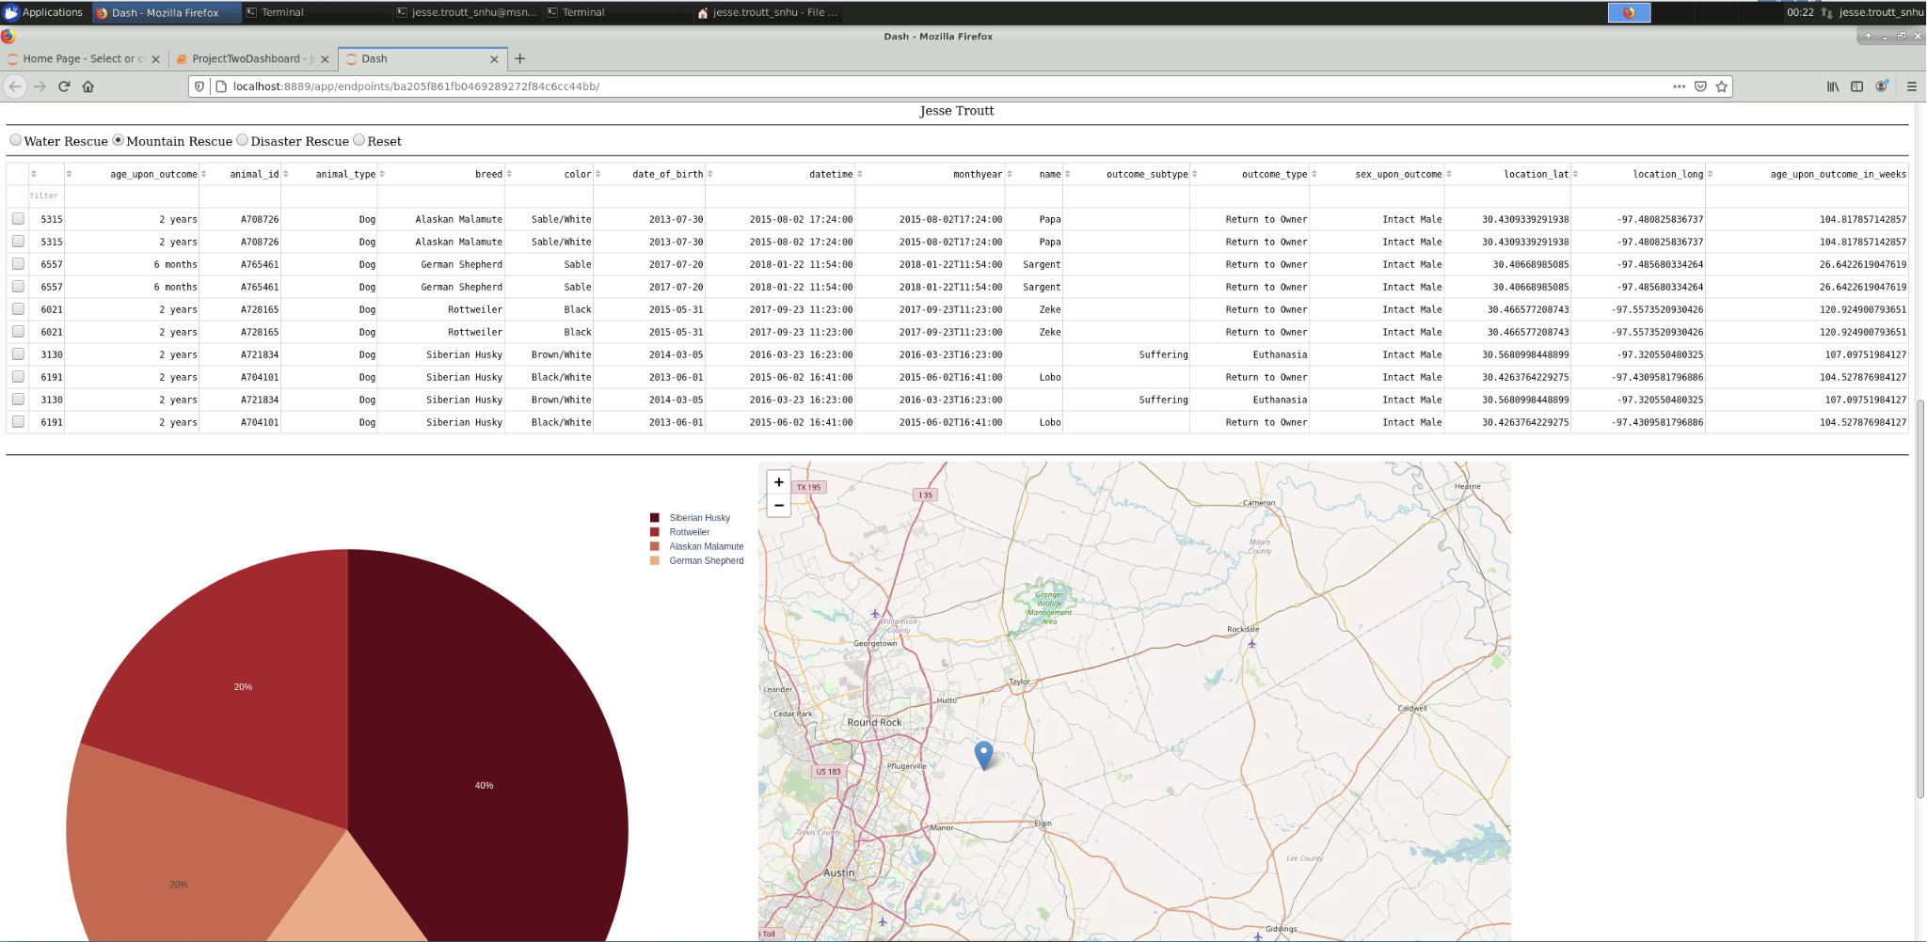

Below is the same table and charts with the Disaster Rescue radio button selected

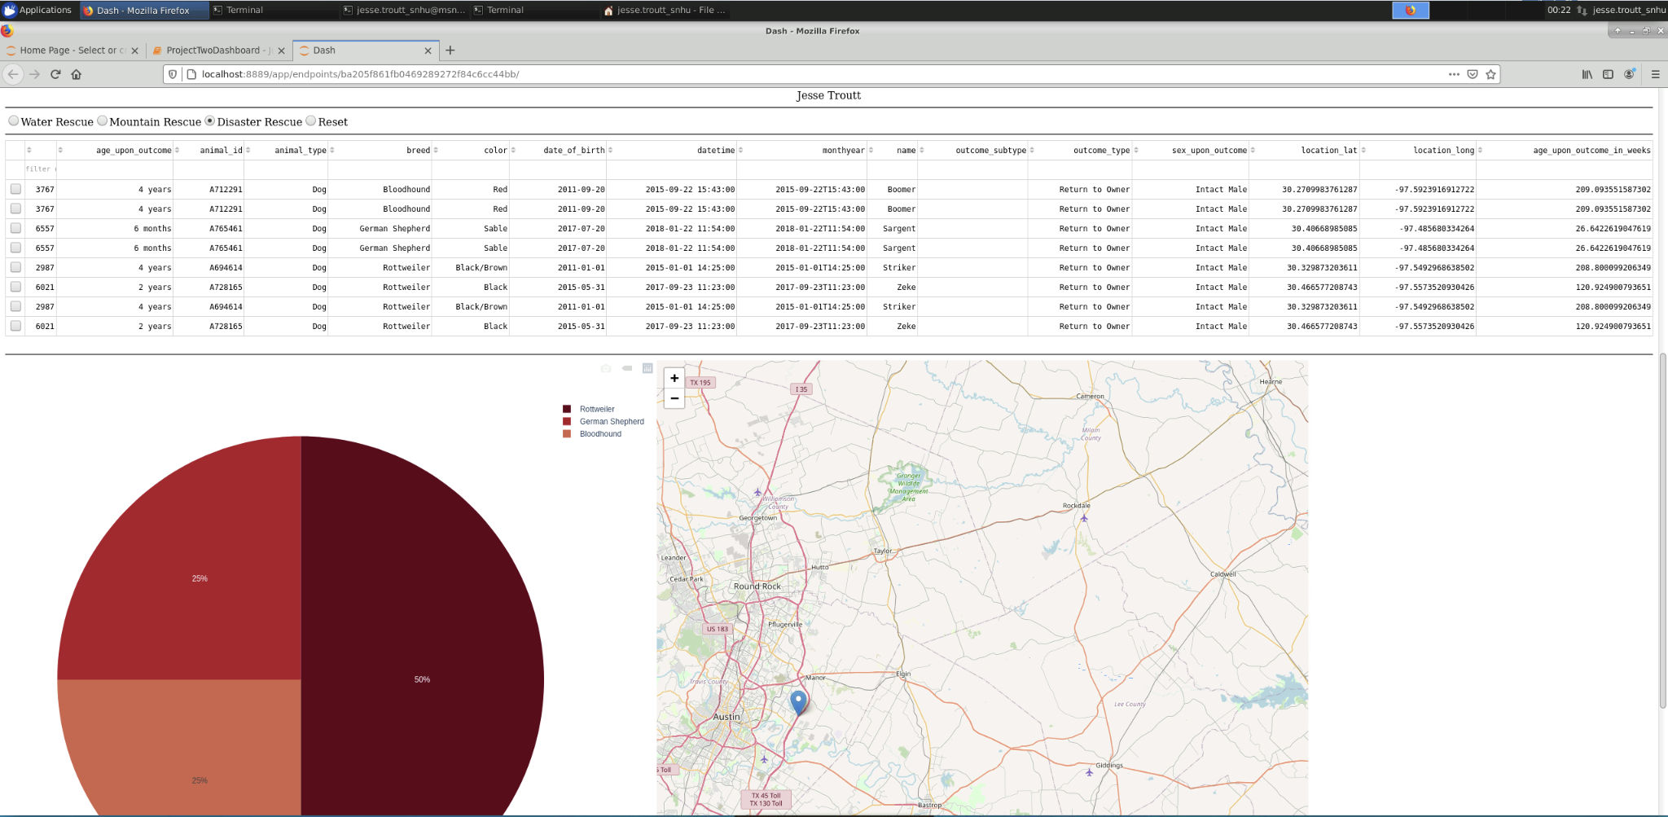

### Screenshots

All screenshots available

**

**

**

**

**

## Contact

Jesse Troutt